Assignment No. 8
Title: Google App Engine.
Problem Statement: Installation and configure Google App Engine.
Objective: Installation and configure Google App Engine.
Outcome: Installation and configure Google App Engine.
Procedure:
Step 1: Go to Google Console and Search App Enigne
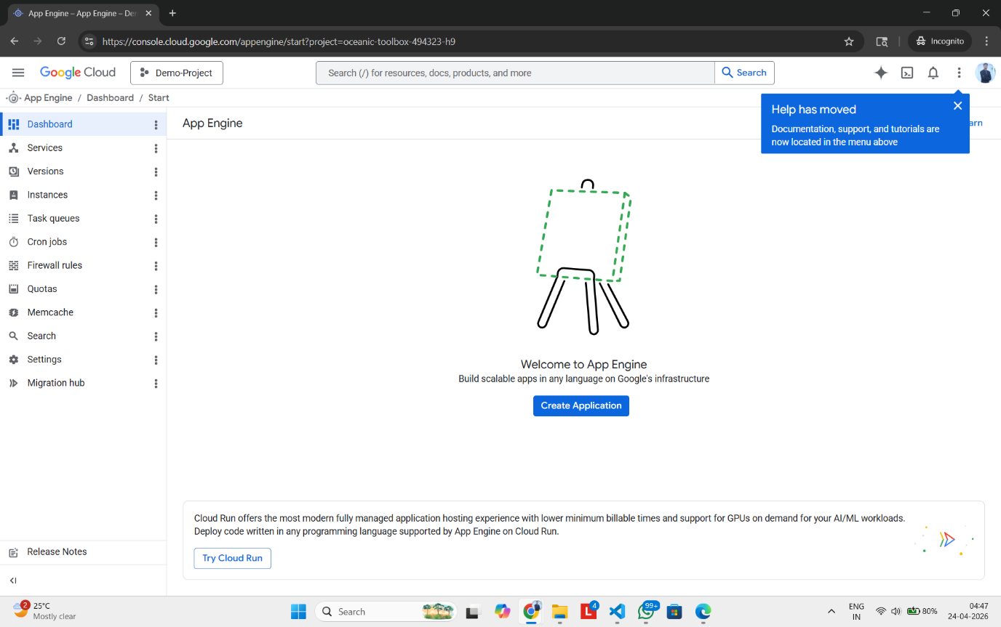

Step 2: Select the region and resources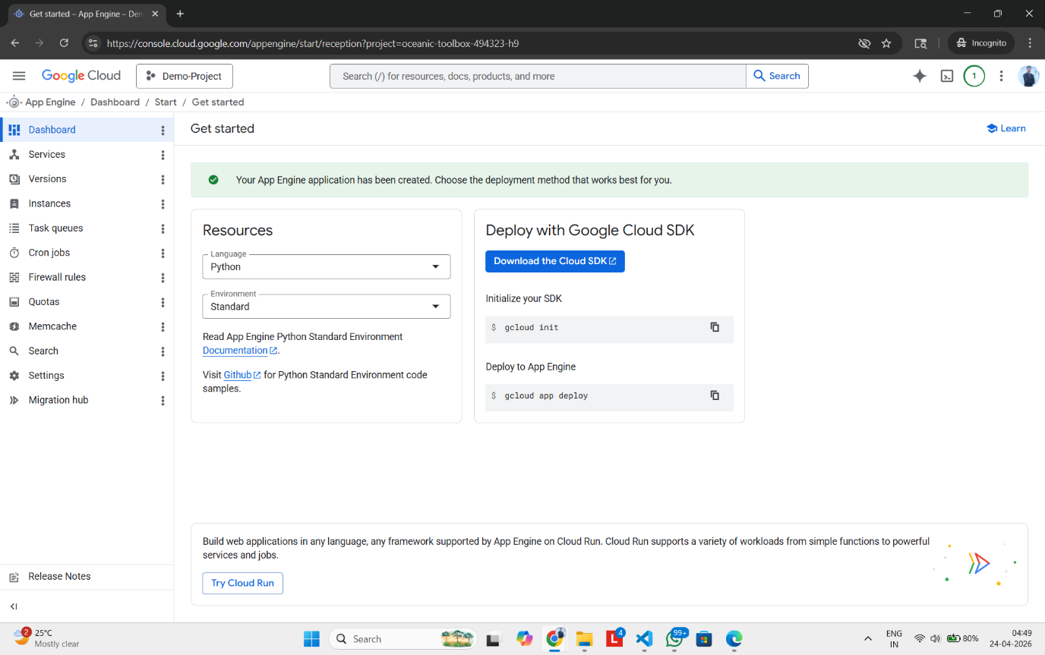

Step 3: Come to terminal and enter ‘gcloud init’
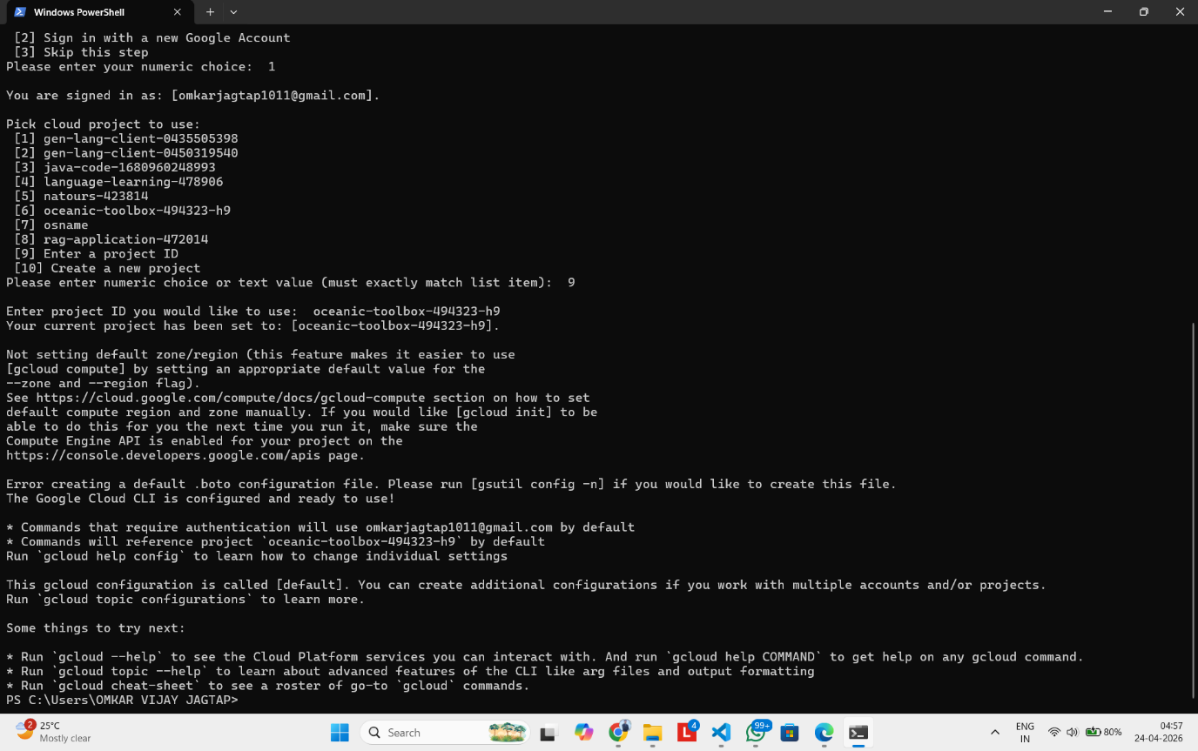

Step 4: Verify Config using ‘gcloud config list’
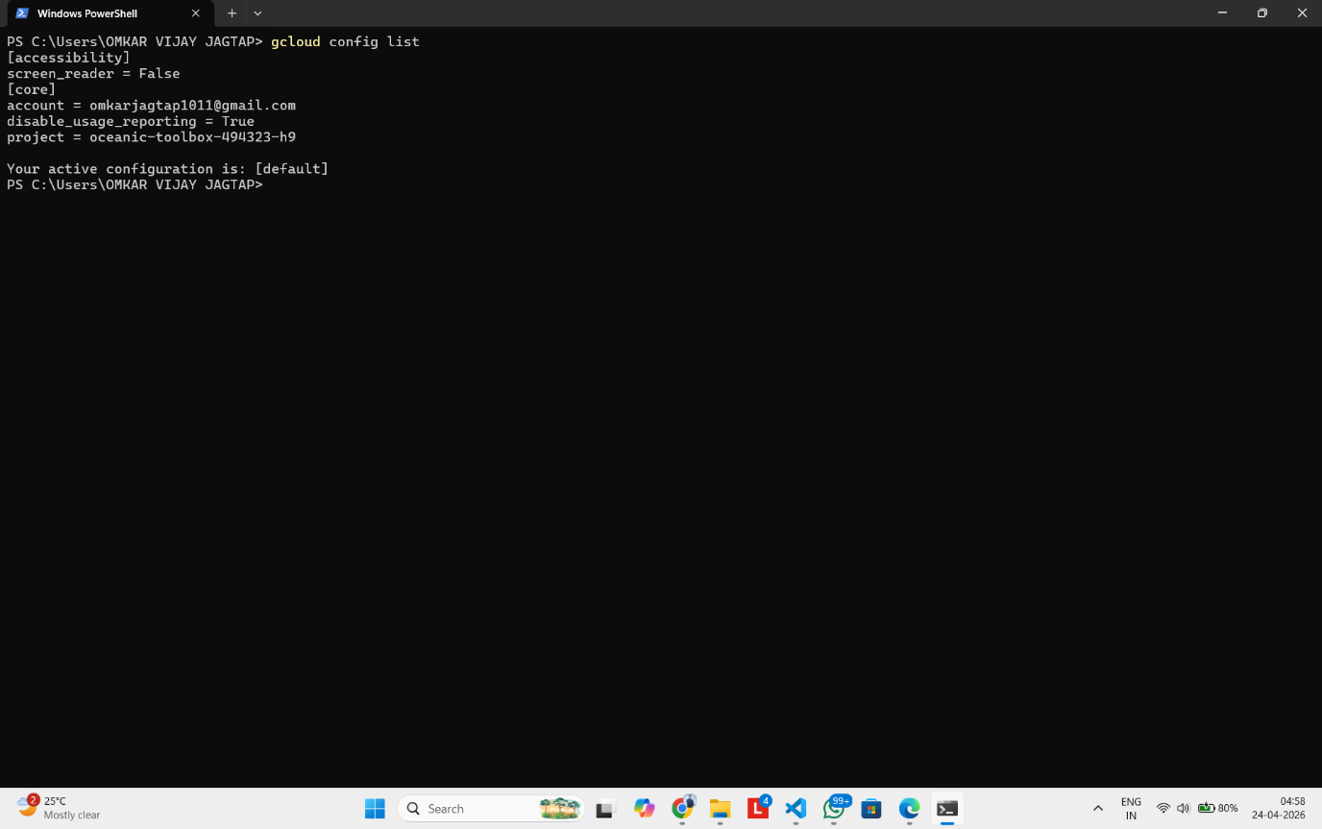

Step 5: Deploy the app using ‘gcloud app deploy’
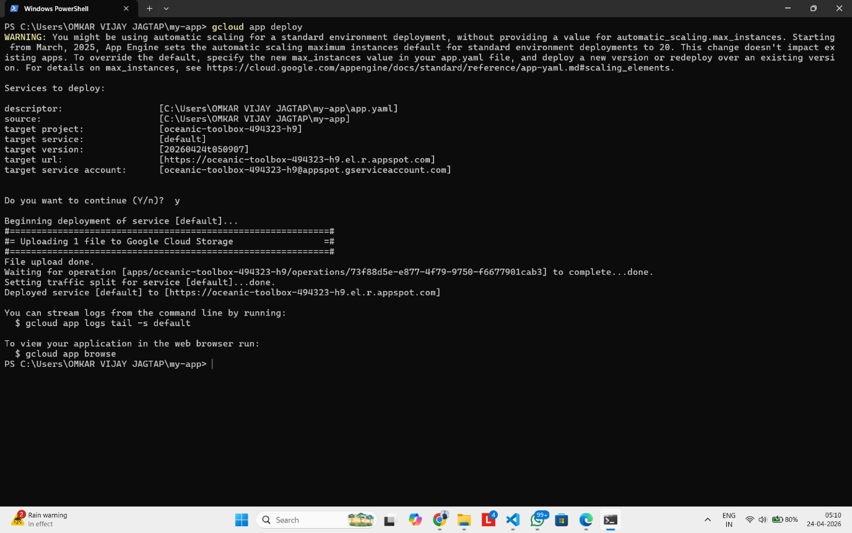

Step 6: Launch app using ‘gcloud app browse’
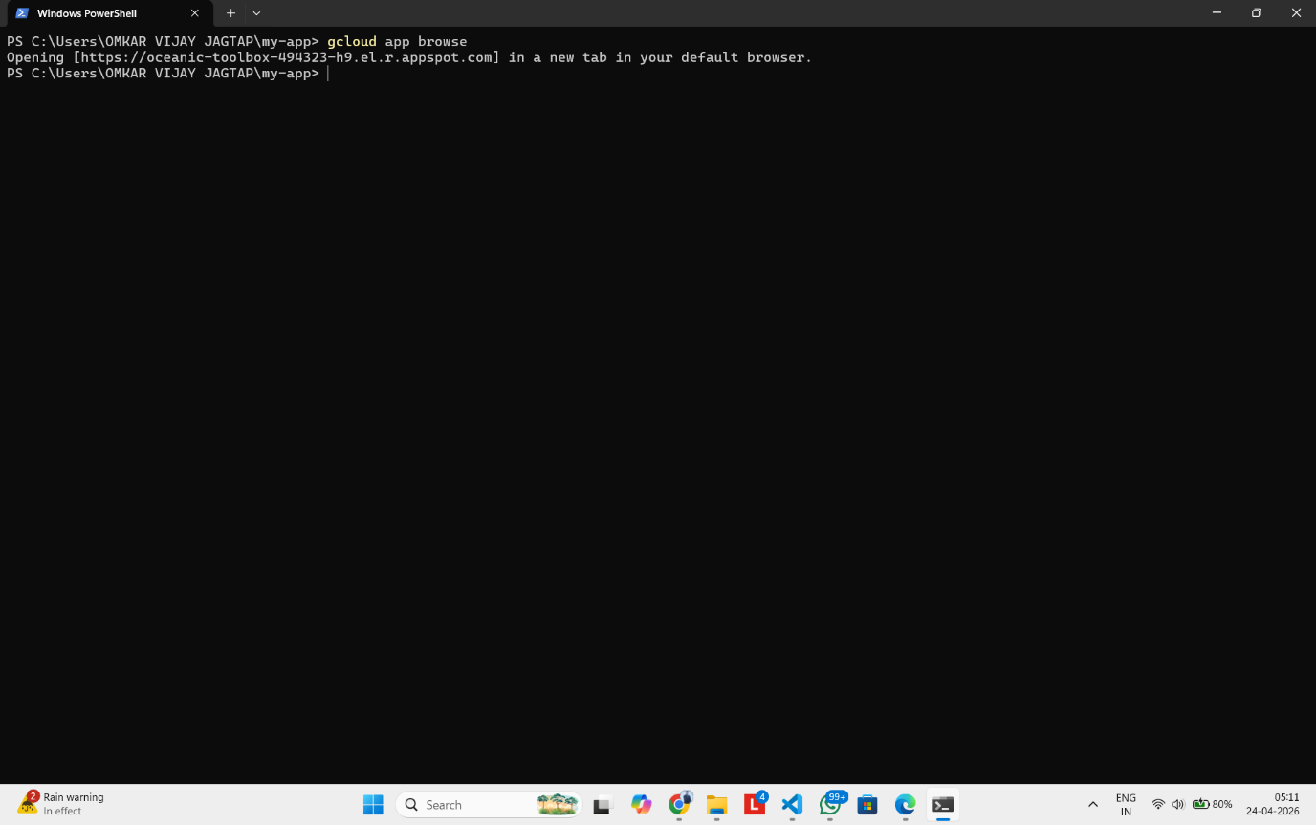

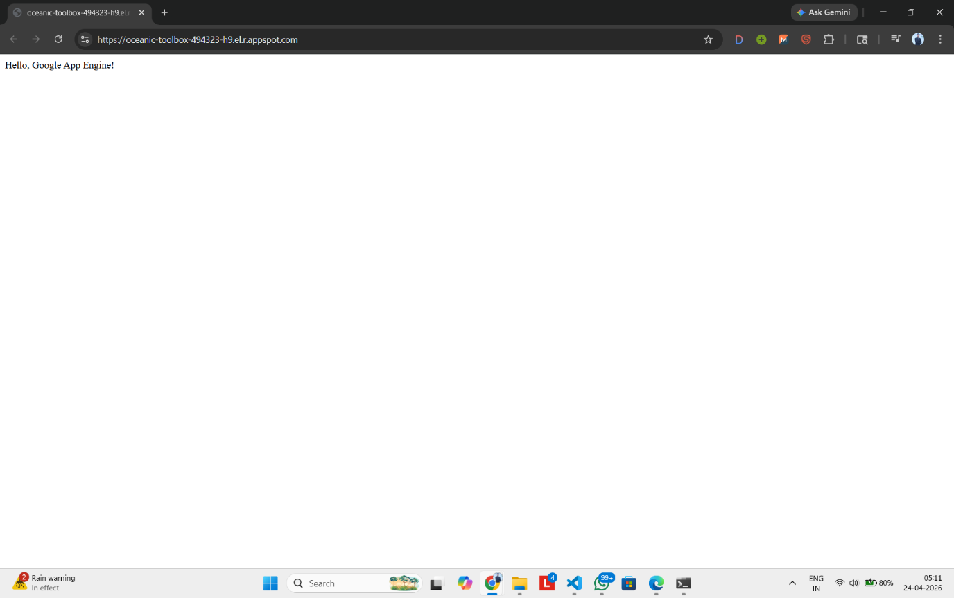

Conclusion: Google App Engine was successfully installed and configured. A simple web application was deployed using the Python runtime. The experiment demonstrated the functioning of the Platform as a Service model and highlighted the difference between PaaS and IaaS cloud services

